EXERCISE 1 OUTPUT:
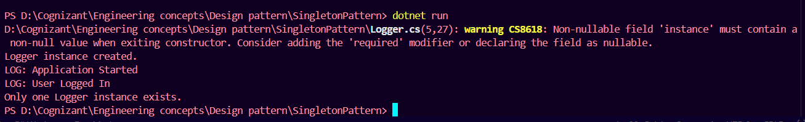

EXERCISE 2 OUTPUT:
